**INFRASTOP INSTALLATION PROCEDURE**

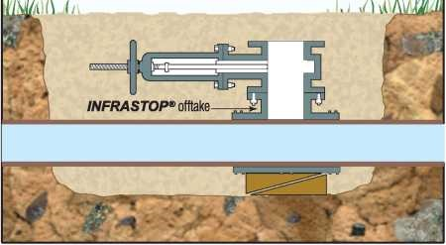

* + - * + Offtake is installed onto cleaned pipeline.
        + Knifegate valve is installed onto offtake.

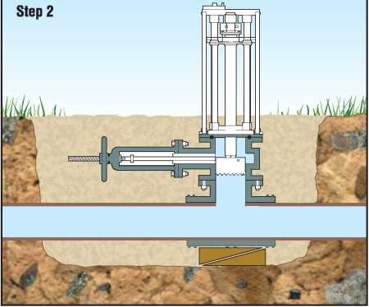

* Hydraulic Drilling Machine with cutter installed onto knifegate valve.
* Hole cut in pipe while under pressure (hot tapped)
* Cutter withdrawn and knifegate closed
* Process repeated with special reamer (AC, DI & CI only)
* Drilling machine removed

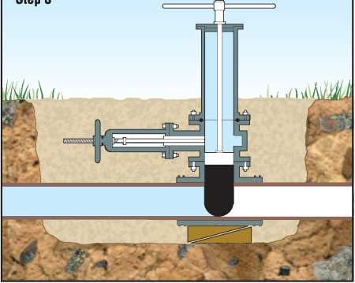

* Insertion chamber with plug inside installed onto knifegate.
* Knifegate opened
* Plug pushed through knifegate and into the hole and seat formed in pipe.
* Plug is installed into position by screwing down by handle on insertion chamber.

Process is reversed by:

* Raising the plug and closing the knifegate valve

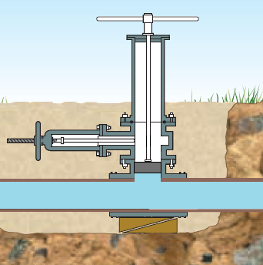

* Use the insertion chamber to screw in the closing plug (shown left)

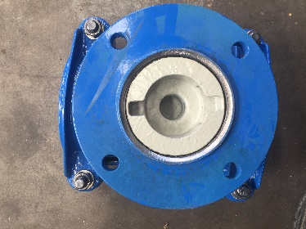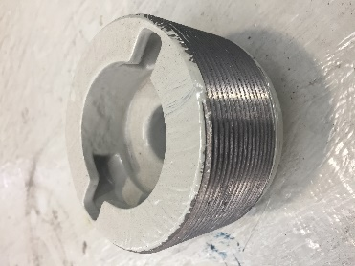

*Closing plug*

*Screwed into the Infrastop by the insertion chamber handle*

*Step 4: Installing the closing plug*

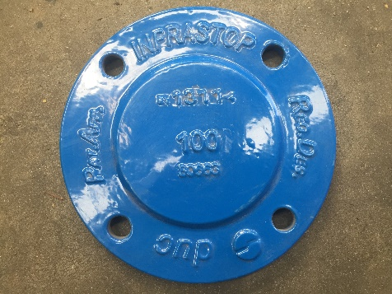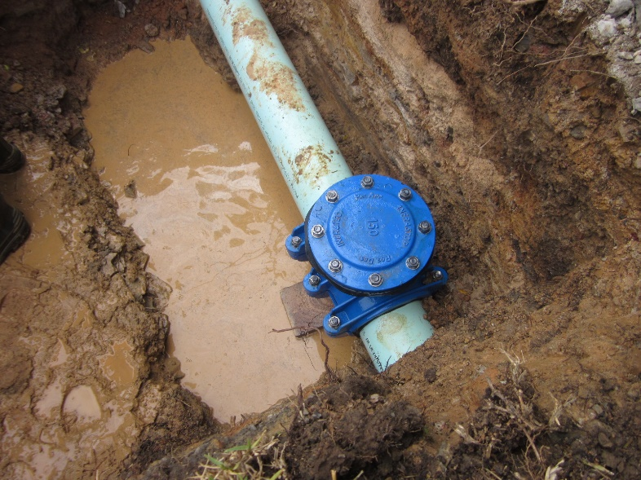

* Once closing plug is installed, remove the insertion chamber and screw on the blank flange.